## **Lab 16: Android Twitter Integration**

# **Introduction**

Your application can connect to Twitter on Android and exchange data or any other updates there. This part explains how to incorporate Twitter into your programme.You can share content from your application and incorporate Twitter in two different ways. Below is a summary of these methods.

**Let’s get Started:**

In this example we will be developing and Android App to Integrate Twitter with Android.

**Step 1:** open **activity_main.xml** file from **\res\layout** folder path and write the code like as shown below.

**activity_main.xml**

<?xml version="1.0" encoding="utf-8"?>

<RelativeLayout xmlns:android="http://schemas.android.com/apk/res/android"

xmlns:tools="http://schemas.android.com/tools" android:layout_width="match_parent"

android:layout_height="match_parent"

android:paddingLeft="@dimen/activity_horizontal_margin"

android:paddingRight="@dimen/activity_horizontal_margin"

android:paddingTop="@dimen/activity_vertical_margin"

android:paddingBottom="@dimen/activity_vertical_margin" tools:context=".MainActivity">

<TextView

android:layout_width="wrap_content"

android:layout_height="wrap_content"

android:id="@+id/textView"

android:layout_alignParentTop="true"

android:layout_centerHorizontal="true"

android:textSize="30dp"

android:text="Twitter share " />

<TextView

android:layout_width="wrap_content"

android:layout_height="wrap_content"

android:text="Tutorials Point"

android:id="@+id/textView2"

android:layout_below="@+id/textView"

android:layout_centerHorizontal="true"

android:textSize="35dp"

android:textColor="#ff16ff01" />

<ImageView

android:layout_width="wrap_content"

android:layout_height="wrap_content"

android:id="@+id/imageView"

android:layout_below="@+id/textView2"

android:layout_centerHorizontal="true"

android:src="@drawable/abc"/>

<Button

android:layout_width="wrap_content"

android:layout_height="wrap_content"

android:text="Share"

android:id="@+id/button"

android:layout_marginTop="61dp"

android:layout_below="@+id/imageView"

android:layout_centerHorizontal="true" />

</RelativeLayout>

**Step 2:** Open main [activity](https://www.tutlane.com/tutorial/android/android-activity-lifecycle) file **MainActivity.java** and write the code like as shown below.

**MainActivity.java**

import android.content.Intent;

import android.net.Uri;

import android.support.v7.app.ActionBarActivity;

import android.os.Bundle;

import android.view.View;

import android.widget.Button;

import android.widget.ImageView;

import java.io.FileNotFoundException;

import java.io.InputStream;

public class MainActivity extends ActionBarActivity {

private ImageView img;

protected void onCreate(Bundle savedInstanceState) {

super.onCreate(savedInstanceState);

setContentView(R.layout.activity_main);

img=(ImageView)findViewById(R.id.imageView);

Button b1=(Button)findViewById(R.id.button);

b1.setOnClickListener(new View.OnClickListener() {

@Override

public void onClick(View v) {

Intent sharingIntent = new Intent(Intent.ACTION_SEND);

Uri screenshotUri = Uri.parse("android.resource://comexample.sairamkrishna.myapplication/*");

try {

InputStream stream = getContentResolver().openInputStream(screenshotUri);

} catch (FileNotFoundException e) {

// TODO Auto-generated catch block

e.printStackTrace();

}

sharingIntent.setType("image/jpeg");

sharingIntent.putExtra(Intent.EXTRA_STREAM, screenshotUri);

startActivity(Intent.createChooser(sharingIntent, "Share image using"));

}

});

}

}

**AndroidManifest.xml**

<?xml version="1.0" encoding="utf-8"?>

<manifest xmlns:android="http://schemas.android.com/apk/res/android"

package="com.example.sairamkrishna.myapplication" >

<application

android:allowBackup="true"

android:icon="@mipmap/ic_launcher"

android:label="@string/app_name"

android:theme="@style/AppTheme" >

<activity

android:name=".MainActivity"

android:label="@string/app_name" >

<intent-filter>

<action android:name="android.intent.action.MAIN" />

<category android:name="android.intent.category.LAUNCHER" />

</intent-filter>

</activity>

</application>

</manifest>

**Step 3: Check Output on Android Emulator and it should look like as given below.**

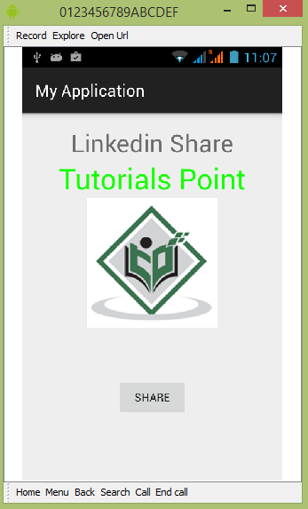

**Voila!!** We have successfully completed this lab.